

COMMON Project 4

Kidus Tilahun



November 12, 2019

|  |  |  |  |  |  |
| --- | --- | --- | --- | --- | --- |
| **Test Case #** | **Input** | **Actual Input** | **Expected Output** | **Actual Output** | **Did the test pass?** |
| 1 | No. of employees :  4  Employee ID’s/Days of absence : 1111 4  1112 5  1113 4  1114 3 | 4  1111  4  1112  5  1113  4  1114  3 | Total: 16  Average: 4.0 | 16  4.0 | yes |
| 2 | No. of employees :  5  Employee ID’s/Days of absence : 1234 2  2234 4  3234 6  4234 9  234 4 | 5  1234  2  2234  4  3234  6  4234  9  234  4 | Total: 25  Average: 5.0 | 25  5.0 | yes |
| 3 | No. of employees :  3  Employee ID’s/Days of absence : 2134 2  2234 4  2334 6 | 3  2134  2  2234  4  2334  6 | Total: 12  Average: 4.0 | 12  4.0 | yes |
| 4 | No. of employees :  2  Employee ID’s/Days of absence : 3334 2  534 4 | 2  3334  2  534  4 | Total: 6  Average: 3.0 | 6  3.0 | yes |
| 5 | No. of employees :  0 | 0 | Error message!!  Enter again | Error message!!  Enter again | yes |
| 6 | No. of employees :  1  Employee ID’s/Days of absence : 3456 0 | 1  3456  0 | Total: 0  Average: 0 | 0  0 | yes |

# Test Tables

1. 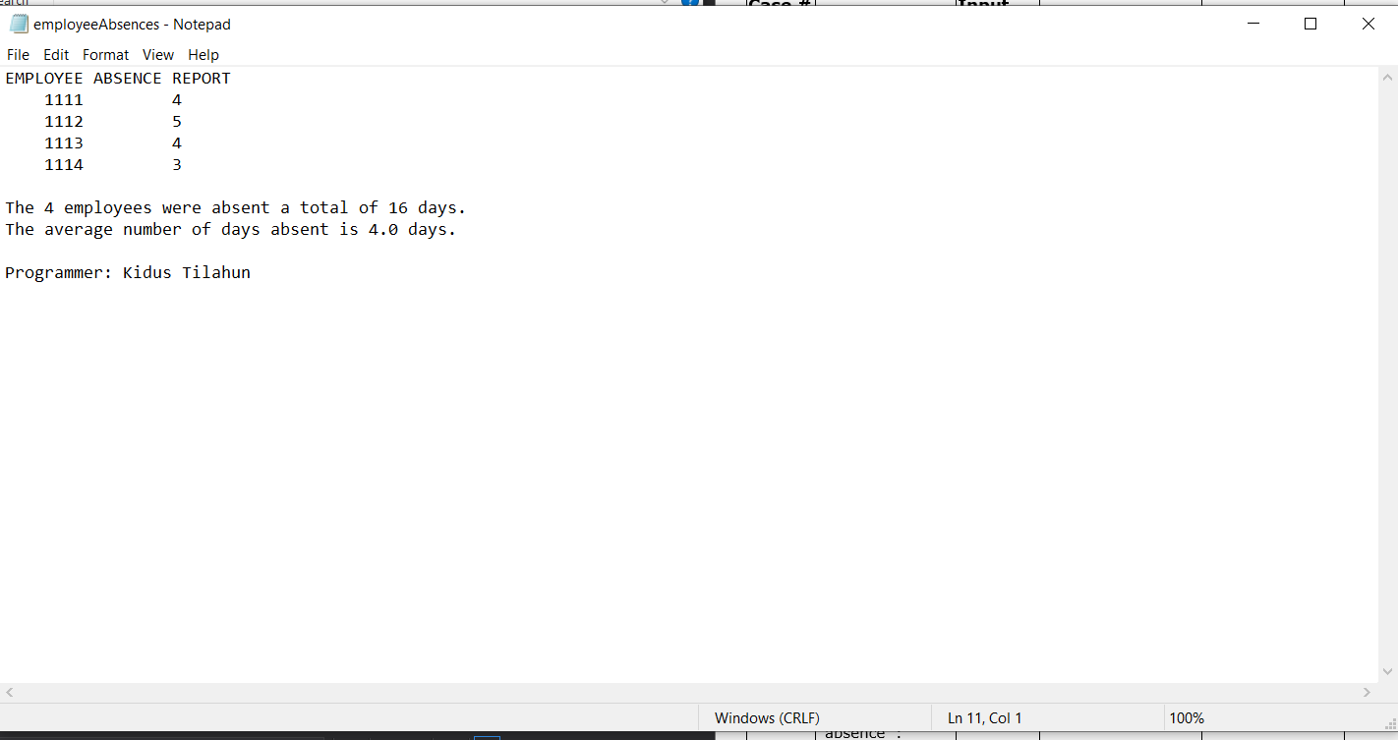
2. 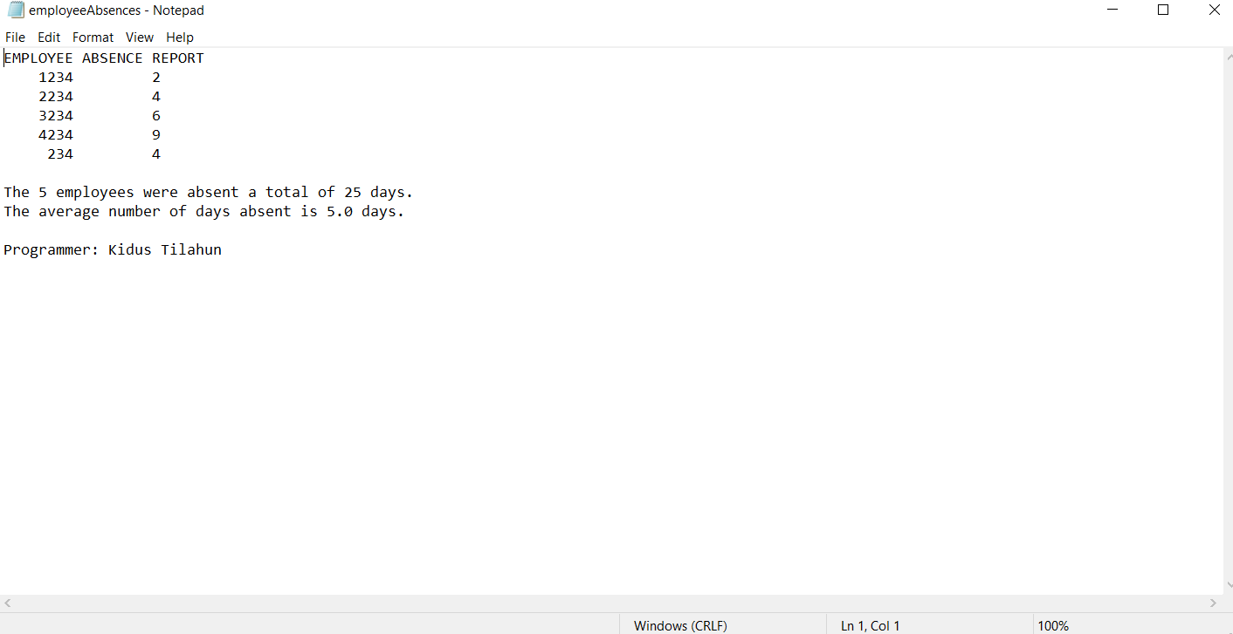
3. 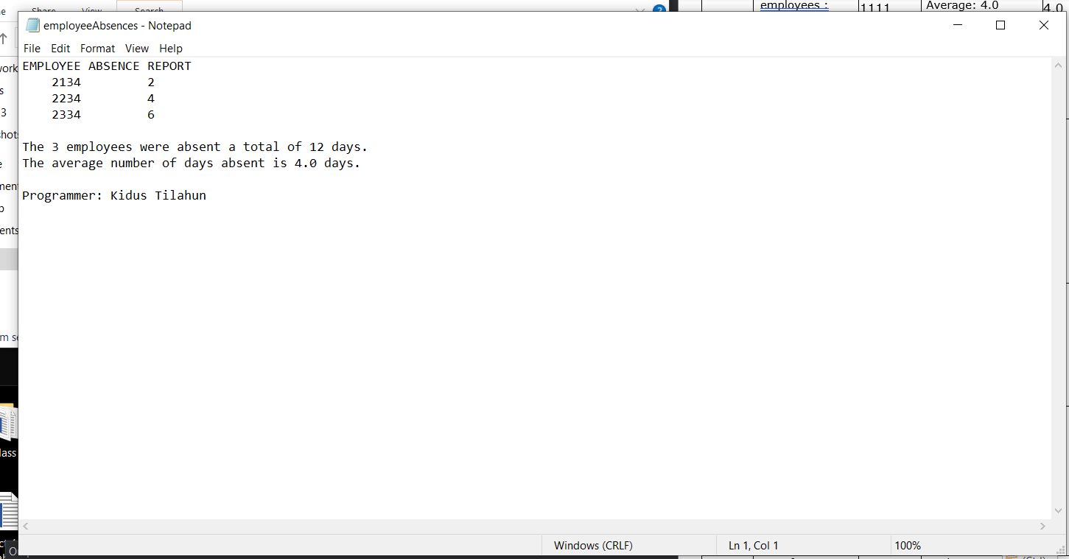
4. 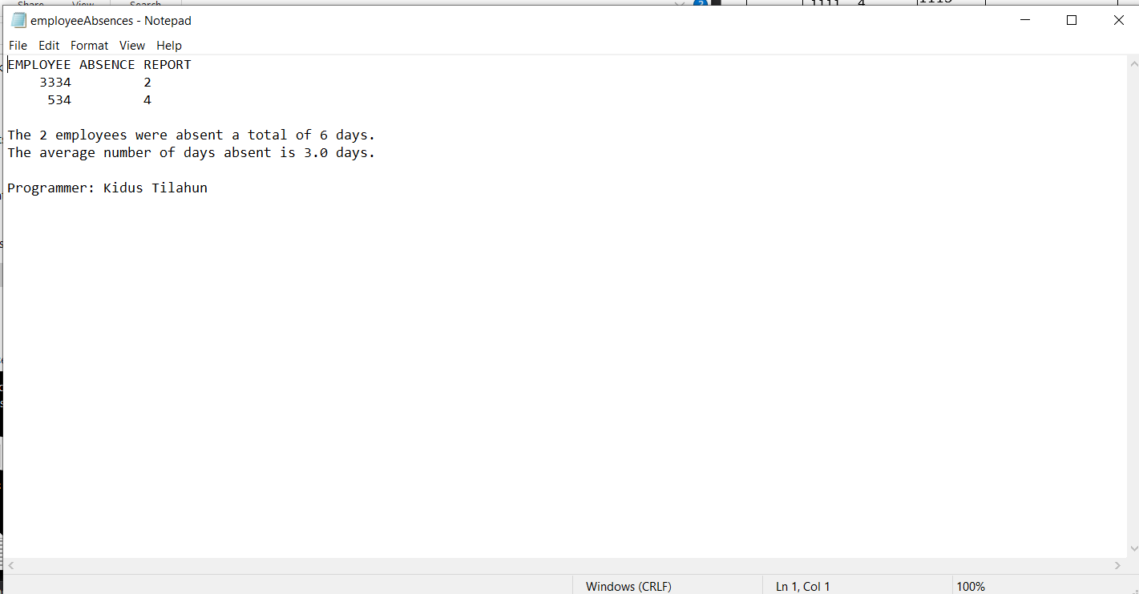
5. 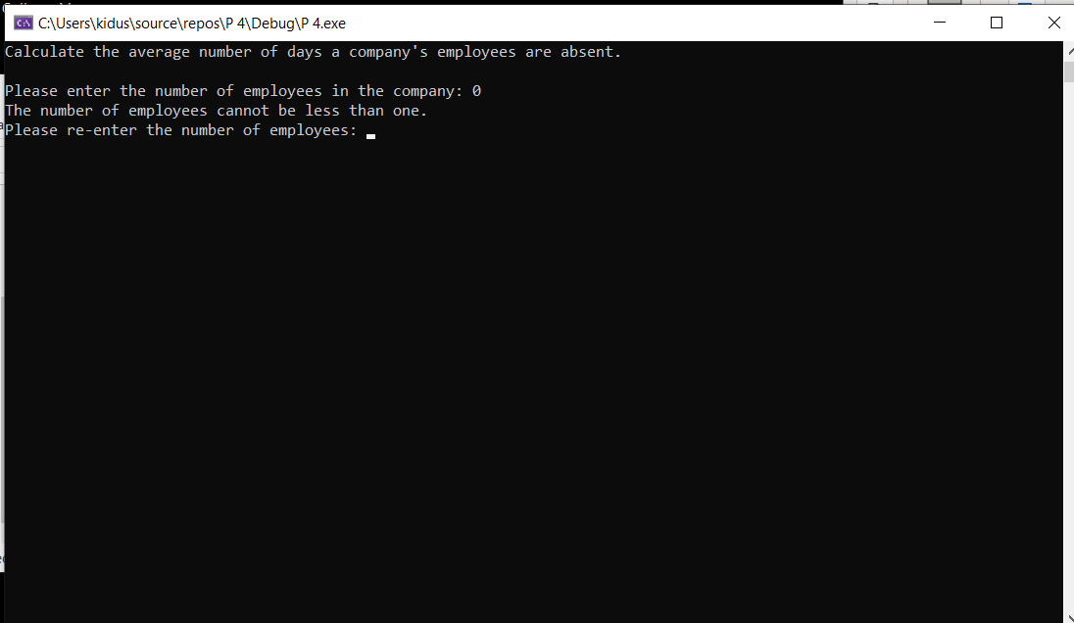
6. 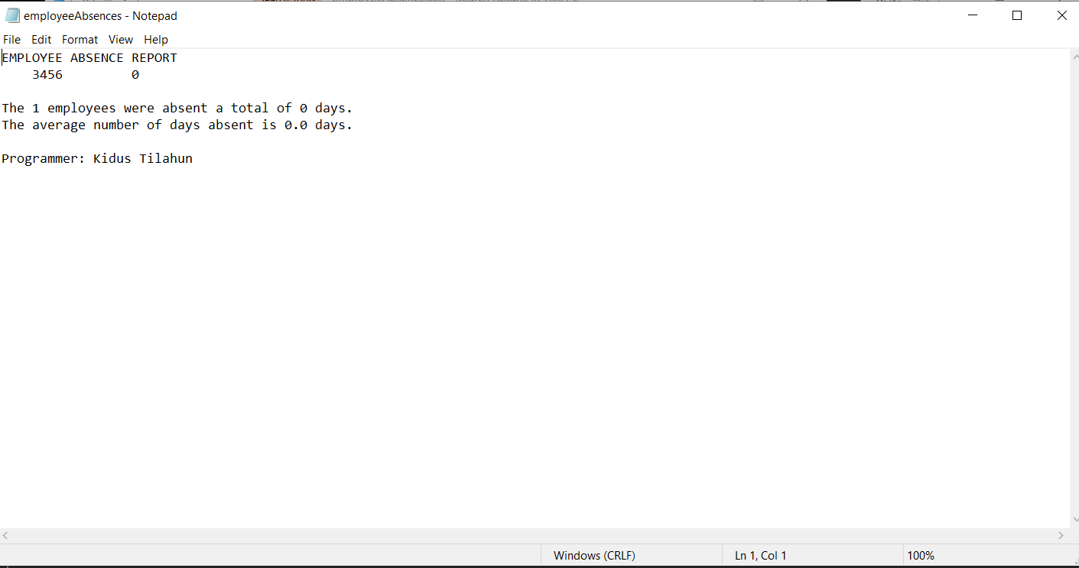

# Lesson Learned

One of the most important lessons I learned in this project was through a problem. The problem I faced was with moving data from a one function to the other. But I eventually figured out how to use the return value and solved the problem.